Literacy support worksheet

1.1 Scientists review the research of other scientists

Pages 2–3

Scientific research

1 Which scientist is called the ‘father of genetics’?

|  |
| --- |
|  |

2 What type of plant did Gregor Mendel study to discover genetics?

|  |
| --- |
|  |

3 Name the two important principles Mendel identified that form the basis of genetics today.

|  |
| --- |
|  |
|  |

4 According to Mendel, we inherit our characteristics or traits in pairs of factors, or genes. Where do we get these from?

|  |
| --- |
|  |
|  |

5 Why do people call George Mendel the ‘father of genetics’?

|  |
| --- |
|  |
|  |

6 If you inherit your curly hair from your father, does this mean you will also inherit your father’s blue eyes? Give a reason for your answer.

|  |
| --- |
|  |
|  |

7 Connect the scientist with their contribution to genetics.

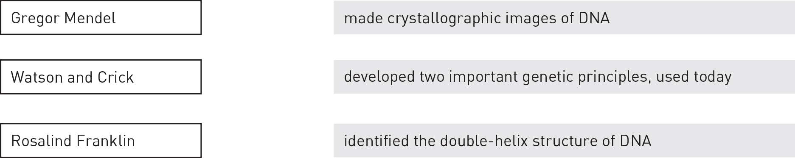

Word detective – Fill in the table

8 Gregor Mendel studied different traits of pea plants. Use the following word list to fill in the table below:

Word list: Round, Seed colour, Thin, Purple, Yellow, White, Pod colour, Green, Tall

|  |  |  |  |
| --- | --- | --- | --- |
| Characteristic | Example 1 | | Example 2 |
| Seed shape | |  |  |
|  | | Yellow |  |
| Flower colour | |  |  |
|  | | Green |  |
| Stem height | |  | Short |

Literacy support worksheet

1.2 DNA consists of a sugar-phosphate backbone and four complementary nitrogen bases

Pages 4–5

The composition of DNA

1 Name the chemical that all genes are made up of.

|  |
| --- |
|  |

2 Where is DNA found?

|  |
| --- |
|  |

3 What kind of cell has no DNA?

|  |
| --- |
|  |

4 DNA is made up of nucleotides. What 3 building blocks make up a nucleotide?

|  |
| --- |
|  |
|  |
|  |

5 Label the three building blocks of a nucleotide on the diagram below.

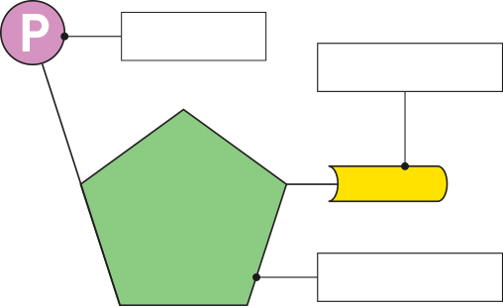

6 There are four nitrogen bases (listed below). Draw a line to match the base with its pair.

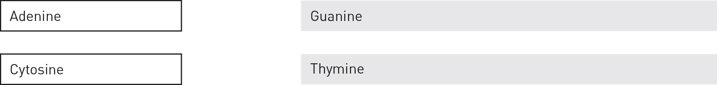

7 Describe the two vital roles of a DNA molecule.

|  |
| --- |
|  |
|  |

Word detective – Draw and label

8 Draw and label a diagram of a DNA double helix. Be sure to label the nitrogen bases. (Hint: You can use Figure 1.8 in the student book to help you.)

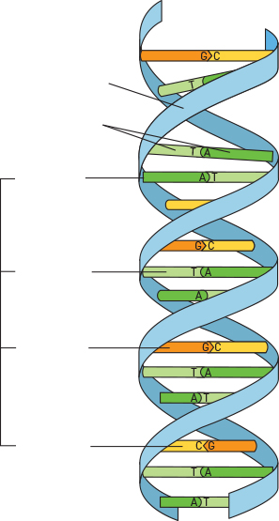

Literacy support worksheet

1.3 Chromosomes are DNA molecules carrying genetic information in the form of genes

Pages 6–9

Chromosomes

1 Which is larger, a gene or a chromosome?

|  |
| --- |
|  |

2 Circle the sex chromosomes shown in in the human karyotype below.

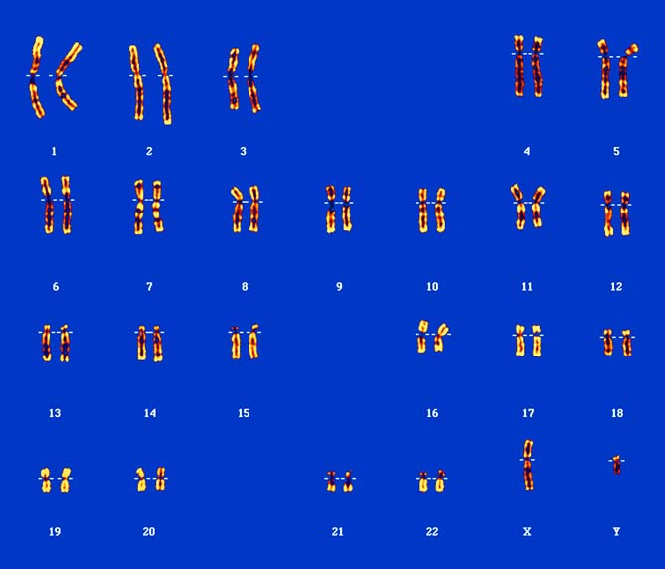

3 Is the karyotype above for a male or a female? How do you know?

|  |
| --- |
|  |
|  |

4 What happens when a protein needs to be made?

|  |
| --- |
|  |
|  |

5 How many chromosomes do you inherit from your mother? From your father?

|  |
| --- |
|  |
|  |

6 Name the two processes shown in the diagram below.

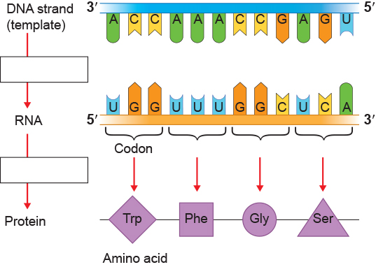

7 We have learnt that the following pairs of nitrogen bases always pair together:

Thymine (T) – Adenine (A) Guanine (G) – Cytosine (G)

Use the example in part a to help you complete part b below.

|  |  |  |  |
| --- | --- | --- | --- |
| a | DNA template: GAT ACC GCA TTC | b | DNA template: TAC GCC TCG ATT |
|  | RNA sequence: CUA UGG CGU AAG |  | RNA sequence: \_\_\_\_\_\_\_\_\_\_\_\_\_\_\_\_\_\_\_\_\_\_\_\_\_ |

Word detective – Complete the Venn diagram

8 Complete the Venn diagram to compare the similarities and differences between DNA and RNA. The first key word has been completed for you.

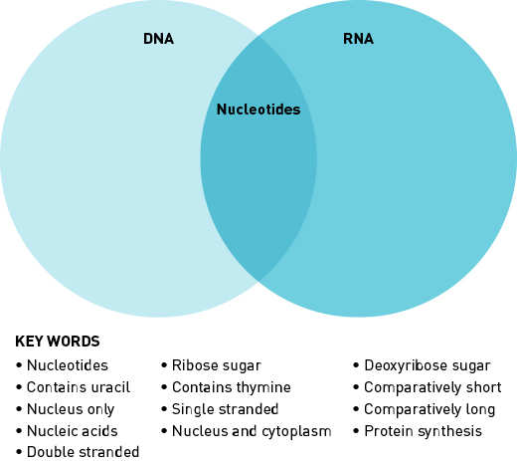

Literacy support worksheet

1.4 Mitosis forms new somatic cells

Pages 10–11

Mitosis

1 Match each term with the correct definition.

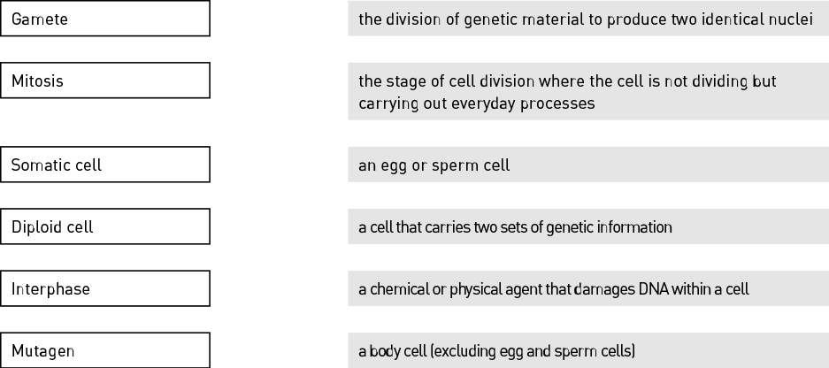

2 Name the cells in the body that do not undergo mitosis.

|  |
| --- |
|  |
|  |

3 Identify the stage of mitosis shown in the following image.

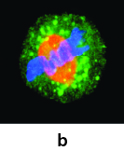

|  |
| --- |
|  |

4 Complete the following sentence:

‘Mitosis is essential for an organism to \_\_\_\_\_\_\_\_\_\_\_\_\_\_\_\_\_\_\_\_\_\_\_\_\_\_\_\_\_\_\_\_\_\_\_\_\_\_\_\_\_\_\_\_\_\_.’

5 If something goes wrong in a cell, programmed cell death occurs. What is this called?

|  |
| --- |
|  |

6 Name three ways the DNA of a cell can become damaged.

|  |
| --- |
|  |
|  |
|  |

7 Why is it that some cancer cells keep on dividing (mitosis) instead of dying (apoptosis)?

|  |
| --- |
|  |
|  |
|  |

Word detective – Label the diagram

8 Label the stages of mitosis shown in the diagram below.

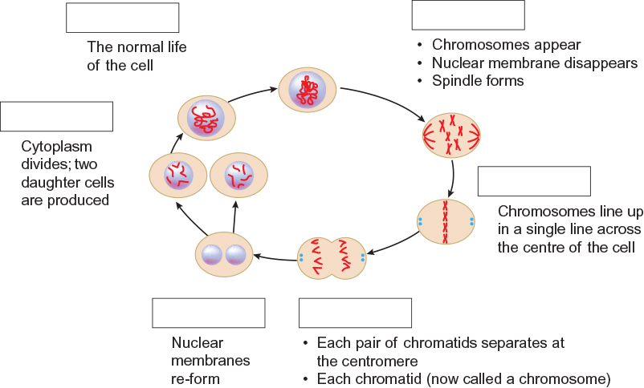

Literacy support worksheet

1.5 Meiosis forms gamete cells

Pages 12–13

Meiosis

1 What is a gamete cell?

|  |
| --- |
|  |

2 Use the following word list to fill in the blanks in the sentence below.

Word list: diploid, egg, chromosomes, mother

When the \_\_\_\_\_\_\_\_\_\_\_ and sperm combine at fertilisation, a \_\_\_\_\_\_\_\_\_\_\_\_\_\_ somatic cell is produced – one set of 23 \_\_\_\_\_\_\_\_\_\_\_\_\_\_\_\_\_\_\_\_\_\_\_\_\_comes from the \_\_\_\_\_\_\_\_\_\_\_\_\_\_\_\_ and one from the father.

3 Circle the correct answer. A haploid gamete in a human, has:

a 46 chromosomes

b 23 chromosomes

4 Fill in the table below:

|  |  |  |
| --- | --- | --- |
| Organism | Male gamete | Female gamete |
| Humans |  |  |
| Plants |  |  |

5 Circle the correct answer to complete the sentence below.

‘In meiosis the number of chromosomes is\_\_\_\_\_\_\_\_\_\_.’

a halved

b doubled

c tripled

6 Meiosis only occurs in gametes, but mitosis only occurs in cells that are not gametes.

Complete the table below by writing whether meiosis or mitosis occurs in each cell type.

|  |  |
| --- | --- |
| Cell type | Type of cell division |
| Bone cell |  |
| Ovum |  |
| Guard cell |  |
| Skin cell |  |
| Sperm cell |  |

Word detective – Draw a flow diagram

7 Draw and label the process of meiosis.

|  |
| --- |
|  |

Literacy support worksheet

1.6 Alleles can produce dominant or recessive traits

Pages 14–15

Alleles

1 What is an allele?

|  |
| --- |
|  |

2 Fill in the blank to complete the sentence.

‘When there is a unique combination of alleles for a gene inherited from parents, it is called a \_\_\_\_\_\_\_\_\_\_\_\_\_\_\_\_\_\_\_\_\_\_\_\_\_\_.’

3 The diagram below is of a pair of chromosomes and shows the alleles for hair colour.

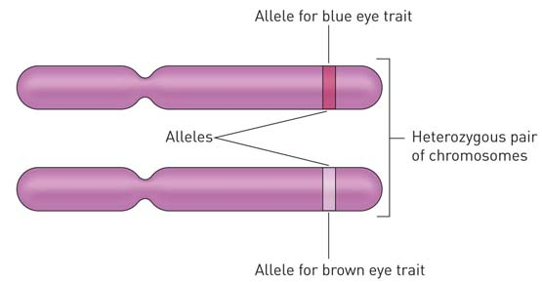

For eye colour (B) of this individual, determine:

a genotype: .

b phenotype: .

4 Circle the correct answer to complete the sentence.

‘Homozygous individuals have\_\_\_\_\_\_\_\_\_\_\_.’

a two identical alleles

b two different alleles

5 Circle the correct answer to complete the sentence.

‘Recessive traits need\_\_\_\_\_\_\_\_\_\_\_.’

a two copies of the allele before it can be expressed

b one copy of the allele before it can be expressed

6 Give an example of a phenotype:

|  |
| --- |
|  |

7 Attached earlobes (E) is dominant to unattached earlobes. Write down the possible genotypes of:

a attached earlobes: .

b unattached earlobes: .

c carriers: .

8 Right-handedness (H) is dominant to left-handedness. A right-handed man and a right-handed woman have two children that are both left-handed. Complete the Punnett square below and indicate how two right-handed parents can have two left-handed children.

|  |  |  |  |
| --- | --- | --- | --- |
|  |  | Father | |
|  |  |  |  |
| Mother |  |  |  |
|  |  |  |

|  |
| --- |
|  |

Word detective – Match the words

9 Match the traits to the gene combinations.

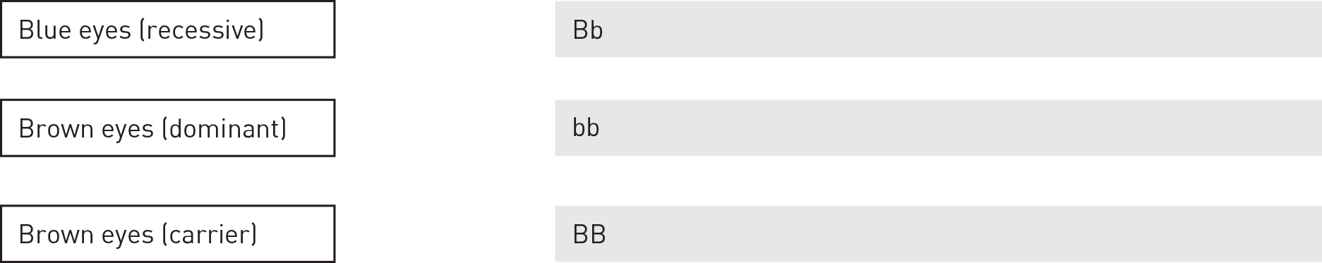

Literacy support worksheet

1.7 Alleles for blood group traits co-dominate

Pages 16–17

Co-dominant traits

1 What is the term used to describe both traits (AB) being expressed equally?

|  |
| --- |
|  |

2 What are the 2 components usually referred to when stating your blood type?

|  |
| --- |
|  |
|  |

3 Use the following word list to fill in the blanks in the sentence below.

Word list: marker, blood, red, Rhesus, negative, none

\_\_\_\_\_\_\_\_\_\_\_\_\_\_\_\_\_\_\_ markers are present on the surface of the \_\_\_\_\_\_\_\_\_\_\_\_\_\_\_\_ blood

cells of 80% of people. If the Rhesus \_\_\_\_\_\_\_\_\_\_\_\_\_\_\_\_\_\_\_\_\_\_ is not present on the red

\_\_\_\_\_\_\_\_\_\_\_\_\_\_\_\_\_\_\_\_\_ cells, the person is said to be Rhesus \_\_\_\_\_\_\_\_\_\_\_\_\_\_\_\_\_\_\_\_\_\_\_\_\_.

4 Which marker do people in blood group O have?

|  |
| --- |
|  |

5 List the 3 different alleles for ABO blood grouping.

|  |
| --- |
|  |

6 Which ABO blood grouping allele is recessive and which alleles are co-dominant?

|  |
| --- |
|  |
|  |

7 Emma has the genotype IAIB and Geoff has the genotype IAi.

a What is Emma’s phenotype? .

b What is Geoff’s phenotype? .

c Draw a diagram in the space below to show how the surface of Emma’s red blood cells differ to those of Geoff’s.

Emma’s red blood cells:

Geoff’s red blood cells:

Word detective – Fill in the Punnett square

8 Fill in the Punnett square to show the possible combinations of genotypic ratios for Emma and Geoff’s children. (Hint: You can use Figure 1.28 in the student book to help you.) The first one has been done for you.

|  |  |  |  |
| --- | --- | --- | --- |
|  |  | Geoff | |
|  |  |  |  |
| Emma |  | IAIA |  |
|  |  |  |

Genotypic ratio: .

Phenotypic ratio: .

Literacy support worksheet

1.8 Alleles on the sex chromosomes produce sex-linked traits

Pages 18–21

Sex-linked traits

1 What are sex chromosomes?

|  |
| --- |
|  |
|  |

2 What are autosomes?

|  |
| --- |
|  |
|  |

3 What are the genotypes (sex chromosomes) of a human:

a male? \_\_\_\_\_\_\_\_\_\_\_\_\_\_\_\_

b female? \_\_\_\_\_\_\_\_\_\_\_\_\_\_\_

4 Identify which is the X chromosome and which is the Y chromosome in the image below:

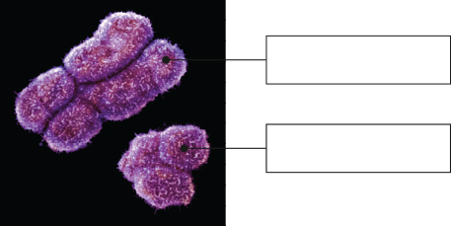

5 What term is used to describe traits and genes that are carried on the sex chromosomes?

|  |
| --- |
|  |

6 Give one example of a trait that is carried on an X chromosome.

7 Match the patterns of inheritance with the correct example.

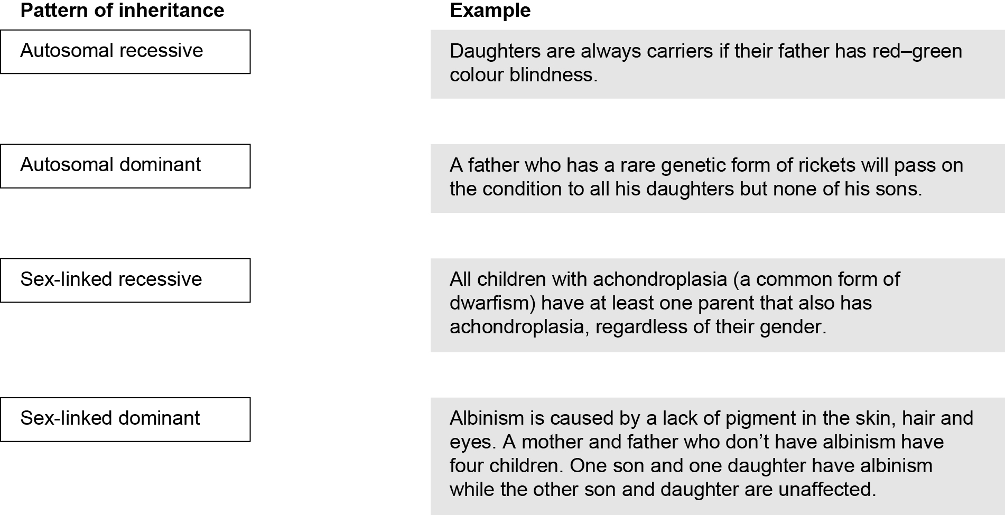

8 What is haemophilia?

|  |
| --- |
|  |
|  |

9 If XH is used to represent a normal gene and Xh is used to represent the gene that carries haemophilia, is Alexis carrying haemophilia or does he have haemophilia?

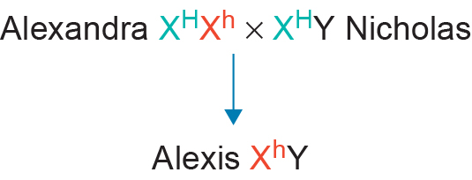

|  |
| --- |
|  |

Word detective – Problem solving

10 A man and a woman both have normal sight. They have four children, two boys and two girls.

One of the boys has normal sight and the other is red–green colour blind.

One of the girls has normal sight and the other is red–green colour blind.

Write the genotypes for this family.

Literacy support worksheet

1.9 Inheritance of traits can be shown on pedigrees

Pages 22–25

Pedigrees

1 What does a pedigree show?

|  |
| --- |
|  |
|  |

2 Match the following pedigree symbols with the correct meaning.

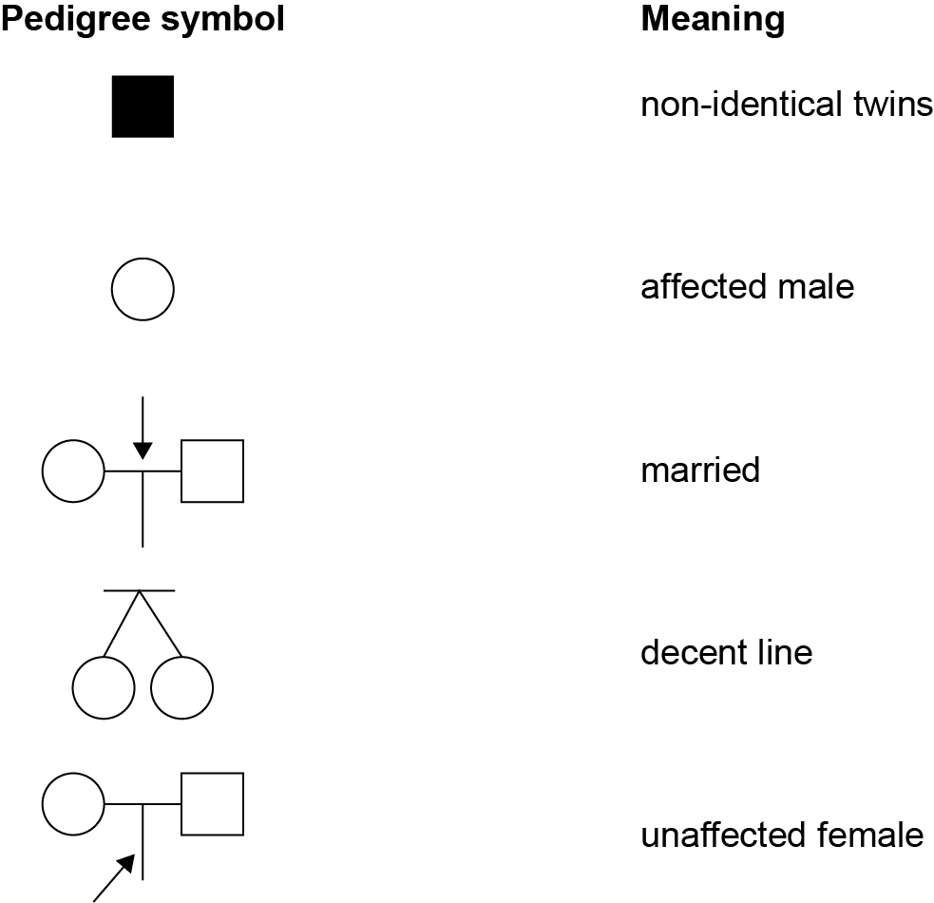

3 What is the symbol in a pedigree for an affected female?

|  |
| --- |
|  |

4 What do Roman numerals represent on a pedigree?

|  |
| --- |
|  |

5 Use the following word list to fill in the blanks in the passage below.

Word list: characteristic, analysing, recessive, none, children, dominant, dominant, dominant

When \_\_\_\_\_\_\_\_\_\_\_\_\_\_\_\_\_ a pedigree to determine whether a trait is \_\_\_\_\_\_\_\_\_\_\_\_\_\_\_\_\_\_\_\_ or recessive, the following rules apply.

• If neither parent has a \_\_\_\_\_\_\_\_\_\_\_\_\_\_\_\_\_\_\_\_ and some of their offspring have it, then the characteristic is \_\_\_\_\_\_\_\_\_\_\_\_\_\_\_\_\_\_\_\_ (i.e. both parents are carrying the allele for the recessive trait but it is not shown in the phenotype).

• If both parents have a characteristic and some of their \_\_\_\_\_\_\_\_\_\_\_\_\_\_\_\_\_\_\_\_ have it, then the characteristic is \_\_\_\_\_\_\_\_\_\_\_\_\_\_\_\_\_\_\_\_ (i.e. both parents are heterozygous).

• If both parents have a characteristic and \_\_\_\_\_\_\_\_\_\_\_\_\_\_\_\_\_\_\_\_ of their children has it, then the characteristic is \_\_\_\_\_\_\_\_\_\_\_\_\_\_\_\_\_\_\_\_ (because, if both parents have a characteristic and it is recessive, then all of their children will have that characteristic because it would have to be on all X chromosomes).

6 The pedigree below shows the inheritance of haemophilia, a sex-linked recessive disease that prevents blood from clotting.

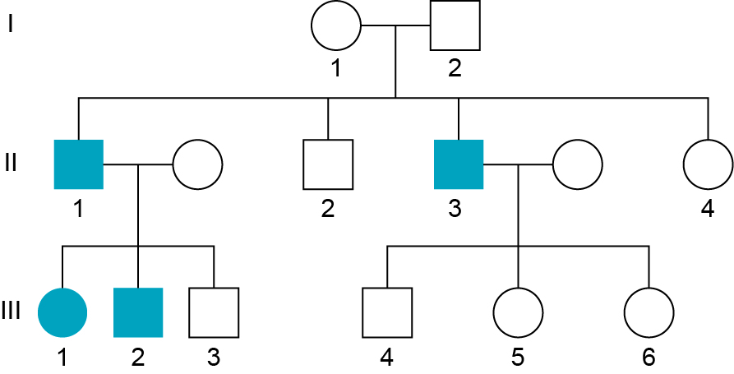

Use the correct symbols to write the genotype of individuals I1 and I2 from the pedigree.

Individual I1: .

* Individual I2: .

7 Analyse the pedigree below to answer the questions that follow.

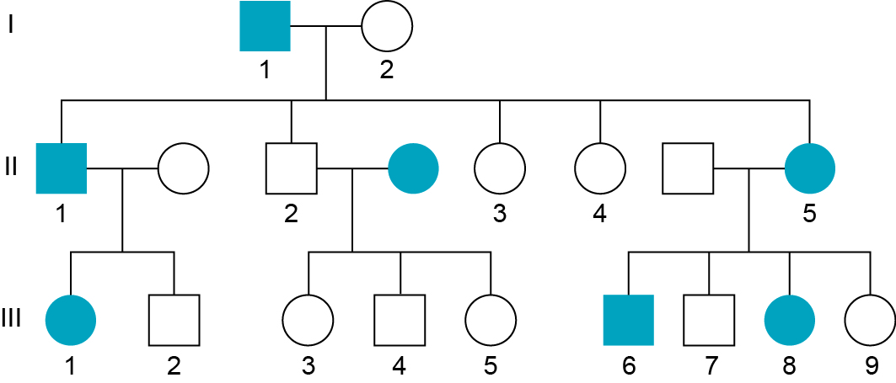

a List the numbers of all the affected males.

|  |
| --- |
|  |

b How many children were born in the second generation?

|  |
| --- |
|  |

Word detective – Sequencing

8 Pedigrees can be analysed to determine whether an individual will inherit a disease. There are a series of questions you should ask when determining the inheritance pattern from a pedigree.

Use your student book to correctly order the questions from 1–5 to determine inheritance.

\_\_\_\_\_\_\_ Has a carrier mother passed it on to half/ some of her sons? YES – Sex-linked recessive

\_\_\_\_\_\_\_\_ Do all affected children have an affected parent? YES – Autosomal dominant. NO, go to 5.

\_\_\_\_\_\_\_ Are more males or females affected by the trait? If YES, go to 2. If NO, go to 3.

\_\_\_\_\_\_\_\_ Do affected children have unaffected parents? YES – Autosomal recessive

\_\_\_\_\_\_\_\_ Do all daughters of affected males have the trait? YES – Sex-linked dominant. NO, go to 4.

Literacy support worksheet

1.10 Mutations are changes in the DNA sequence

Pages 26–29

Mutations

1 Name three types of substances that can cause mutations in DNA.

|  |
| --- |
|  |
|  |

2 Name three ways a nucleotide can be altered.

|  |
| --- |
|  |
|  |

3 Complete the following table by writing the terms for the definitions in the spaces provided.

|  |  |
| --- | --- |
| Term | Definition |
|  | A permanent change in the nucleotide sequence of a single gene. |
|  | Environmental factor that increases the frequency of a mutation. |
|  | A permanent change in the nucleotide sequence of DNA that affects most of a chromosome. |
|  | Forms free radicles that cause damage to DNA and proteins. |
|  | A group of three bases on DNA. |

4 Use the image below to answer the following questions.

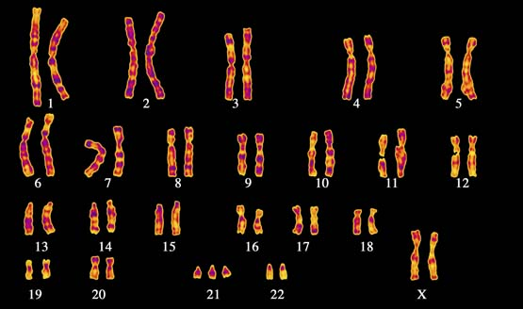

a Which chromosome has had a change in number?

|  |
| --- |
|  |

b What syndrome does this person have?

|  |
| --- |
|  |

c Is this a chromosomal mutation or a genetic mutation?

|  |
| --- |
|  |

5 What is the effect of non-disjunction in sex chromosomes?

|  |
| --- |
|  |

6 Name two types of genetic mutations.

|  |
| --- |
|  |
|  |

7 Circle the correct answer for each of the two questions below:

a A point shift mutation:

a always affects the order of amino acids in a protein.

b may not affect the order of amino acids in a protein.

b A frame shift mutation is when:

a a group of three reading frames have been shifted along the DNA strand.

b a substitution that affects the final protein.

8 Use the following nucleotide sequence to answer the questions.

AGG GAT CCG ATA ACC

a Rewrite the nucleotide sequence to demonstrate a mutation where the first thymine is substituted for guanine.

|  |
| --- |
|  |

b The sequence change in part a is an example of what type of mutation?

|  |
| --- |
|  |

c Rewrite the original nucleotide sequence to demonstrate a mutation where the first thymine is deleted.

|  |
| --- |
|  |

d The sequence change in part c is an example of what type of mutation?

|  |
| --- |
|  |

Word detective – True or false

9 Read the statement and circle whether it is true or false.

a ‘Heritable’ refers to the change being passed to offspring. T or F

b DNA replication never makes mistakes. T or F

c Radiation forms free radicals and damages DNA. T or F

d Sickle cell anaemia is a result in a frame shift mutation. T or F

e Point mutations have more damaging effects than frame shift mutations. T or F

f Some chemicals insert into DNA instead of bases, causing damage. T or F

g Non-disjunction can occur in sex chromosomes. T or F

h Deletion of a base to a chromosome causes more damage than substitution. T or F

Literacy support worksheet

1.11 Genes can be tested

Pages 30–31

Genetic screening and testing

1 What can be used to bind the alleles of individuals at risk of genetic diseases?

|  |
| --- |
|  |

2 Genetic testing can currently be carried out on people at risk for which genetic diseases or conditions?

|  |
| --- |
|  |
|  |

3 State which type of cells DNA is taken from and why.

|  |
| --- |
|  |
|  |

4 Fill in the table below to show the different genetic screening and testing services currently available in Australia.

|  |  |  |
| --- | --- | --- |
| Genetic screening and testing | What individuals are screened? | An example of a disease, disorder or defect being screened |
|  |  |  |
|  |  |  |
|  |  |  |

5 Name two ethical issues with genetic screening.

|  |
| --- |
|  |
|  |

Word detective – Complete a PMI chart

6 Complete a PMI (Plus, Minus, Interesting) chart for genetic testing by copying the appropriate sentences under each heading.

Write a P for Plus, a M for Minus or an I for Interesting to indicate where the sentences or questions should go in the table, then write them in the correct place in the table.

\_\_\_\_\_\_\_\_ What are the risks of the tests that they are prepared to take?

\_\_\_\_\_\_\_\_ The tests may not be accurate.

\_\_\_\_\_\_\_\_ Minimises the frequency of the diseases in future generations.

\_\_\_\_\_\_\_\_ Increases early diagnosis.

\_\_\_\_\_\_\_\_ The testing may not pinpoint the impact of the mutation on the baby.

\_\_\_\_\_\_\_\_ What options are available if it is not good news?

\_\_\_\_\_\_\_\_ If I am a carrier, should I have kids if they may have a genetic disease?

\_\_\_\_\_\_\_\_ If the tests are not correct, this may impact parent decisions.

\_\_\_\_\_\_\_\_ Increases early intervention to help those with genetic diseases

**Genetic Testing**

|  |  |  |
| --- | --- | --- |
| Plus | Minus | Interesting |
|  |  |  |
|  |  |  |
|  |  |  |

Literacy support worksheet

1.12 Genes can be manipulated

Pages 32–33

Manipulating genes

1 Name the four nucleotides that allow DNA to be transferred.

|  |
| --- |
|  |
|  |

2 Write the terms for the definitions in the table below:

|  |  |
| --- | --- |
| Term | Definition |
|  | Organisms that have had their DNA altered to enhance desirable traits |
|  | Organisms that have had DNA from a different species incorporated into their genome |
|  | The entire set of DNA of an organism |
|  | All the different species within a particular area |

3 Name three advantages of GM food, plants and animals.

|  |
| --- |
|  |
|  |

4 What are some possible disadvantages of GM foods?

|  |
| --- |
|  |
|  |
|  |

5 Why might a farmer want to grow GM crops?

|  |
| --- |
|  |
|  |

6 How is this good for the environment?

|  |
| --- |
|  |
|  |

Word detective – Draw and label

7 Draw a series of labelled diagrams to show how a soybean plant can become drought resistant through genetic modification. (Hint: You can use Figure 1.57 in the student book to help you.)

|  |
| --- |
|  |

Literacy support worksheet

1.13 Genetic engineering is used in medicine

Pages 34–35

Genetic engineering

1 What is genetic engineering?

|  |
| --- |
|  |
|  |

2 What is gene cloning?

|  |
| --- |
|  |
|  |

3 Fill in the blanks in the flow diagram below, describing how gene therapy has been used in the treatment of cystic fibrosis.

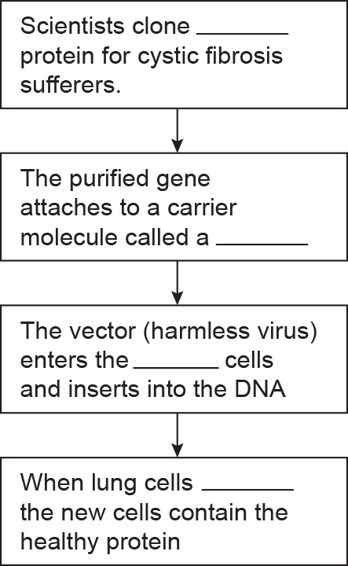

4 Name five types of illnesses that induced pluripotent cells could be used to help in the future.

|  |
| --- |
|  |
|  |
|  |

5 Write the type of stem cell for each of the definitions in the following table.

|  |  |
| --- | --- |
| Type of stem cell | Definition |
|  | Stem cells obtained from embryos that can develop into most cell types in the body. |
|  | Stem cells obtained from body cells that can only develop into certain cell types in the body. |
|  | Multipotent adult stem cells that have been turned back into pluripotent cells. |

Word detective – Sequencing

6 Place the following gene-cloning steps in the correct order by labelling the diagrams as 1–5.

|  |  |  |  |  |
| --- | --- | --- | --- | --- |
| L:\1. Publishing and Editorial\1. Product\Oxford Science\Oxford Science 10\3. Extras\6. Student worksheets\Artwork\4. Final jpgs\SW0132_01095.jpg | L:\1. Publishing and Editorial\1. Product\Oxford Science\Oxford Science 10\3. Extras\6. Student worksheets\Artwork\4. Final jpgs\SW0133_01095.jpg | L:\1. Publishing and Editorial\1. Product\Oxford Science\Oxford Science 10\3. Extras\6. Student worksheets\Artwork\4. Final jpgs\SW0134_01095.jpg | L:\1. Publishing and Editorial\1. Product\Oxford Science\Oxford Science 10\3. Extras\6. Student worksheets\Artwork\4. Final jpgs\SW0135_01095.jpg | L:\1. Publishing and Editorial\1. Product\Oxford Science\Oxford Science 10\3. Extras\6. Student worksheets\Artwork\4. Final jpgs\SW0136_01095.jpg |
|  |  |  |  |  |